Date: September 2016
CEPP Bulletin
State of Colorado Department of Public Safety Division of Homeland Security
John Hickenlooper, Governor Stan Hilkey, Executive Director and Emergency Management
Kevin Klein, Director
September is National Preparedness Month: How Will You Prepare Your Business?
Introduction
As defined by the Department of Homeland Security (DHS) and Federal Emergency Management Agency (FEMA), preparedness is "a continuous cycle of planning, organizing, training, equipping, exercising, evaluating, and taking corrective action in an effort to ensure effective coordination during incident response." In 2004 DHS and FEMA launched a specific section of their Ready campaign in order to help business better prepare their employees, operations and assets in the event of an emergency. This article will cover the preparedness focus areas that the Ready campaign outlines as being essential to achieving this objective: Program Management, Planning, Implementation, Training & Exercise and Program Improvement.
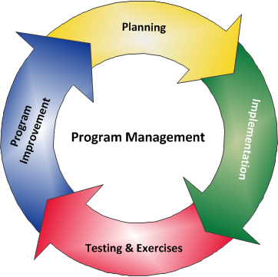

Program Management
Leadership and Commitment
The first and most important component of the Ready business framework is Program Management, specifically Leadership and Commitment. In order to have an effective preparedness program, leadership must be engaged and support the effort. Without this, a program could be halted before it even gets off the ground due to lack of allocated resources and funds.
Preparedness Policy
Having a policy in place that is constituent with your business’s mission and vision is very important. It must include the roles and responsibilities employees have to prepare and the goals and objectives of the program. Examples of these goals and objectives are keeping employees and guests of the business safe, protecting physical infrastructure and safeguarding essential data that keeps the business operating.
Program Committee and Program Coordinator
In order for a successful preparedness program to be developed, there must be people in place designated to the development, implementation and maintenance of the program. A program coordinator should be assigned to oversee the committee’s efforts to achieve management’s goals and objectives. He or she should also be responsible for the outreach to employees about the program plans and policies and encourage their participation. Committee members should include employees with a diverse knowledge of the business. They will assist in the development, implementation, and evaluation of the program. It is also important to consider adding external stakeholders to the conversation. This could include local law enforcement, emergency medical services, public health, contractors, customers and others. DHS and FEMA suggest using the Program Coordinator and Committee Worksheet to identify members of your program committee and to record contact information.
Performance Objectives
Performance objectives for your business plan should include hazard prevention/deterrence, risk mitigation, emergency response and business continuity. DHS and FEMA make the following suggestions to consider: 1) goals and objectives for managing risk, investing in resources, establishing capabilities through training and exercising and complying with regulations and 2) both short-term objectives for the development of the program and long-term objectives that may require more significant planning or investment. Remember that objectives should always be tangible and measurable.
Program Administration
The scope of your preparedness program should be determined by your industry, complexity of operations and information obtained from the risk assessment and business impact analyst (see further information the Planning section below). Regulations will determine the minimum requirements for your program.
Financial needs for the program should be addressed by the creation of a program budget that includes allocation of funds for exercise and training and evaluations of the program. In addition to the budget, DHS and FEMA provide the following advice for developing finance and administrative procedures:
- Procedures should be established for procuring resources before, during and following an incident. A quick process to authorize funds to procure resources will reduce delays.
- Procedures that account for labor, materials and other costs associated with a hazard should be established before an incident. Risk management or insurance procedures for notification of insurance agents, brokers or underwriters should be included.
- Procedures for filing property damage, workers’ compensation and liability claims should be referenced in the plan.
DHS and FEMA advise businesses to create a program development schedule to track the progress of major tasks, assignments and due dates. The program should also be reviewed regularly using the performance objectives identify at the onset to ensure the program is on track. Adjustments should be made as needed.
Lastly, it is important to comply with your business’s records management policies. Make sure to keep records of committee meetings, training, exercise, evaluations and corrective actions. Also consider filing records of inspections, testing and maintenance of fire protection, life safety, communications and other systems and equipment, which may be required by regulation.

Laws & Authorities
The following are some laws and guides that a business should review while developing their preparedness program:
- U.S. Occupational Safety and Health Administration (OSHA) Resources and Guidelines
  - Emergency action plans - OSHA standard that applies to many employers of 10 or more employees
    - OSHA’s Evacuation Plans and Procedures eTool is a great resource to determine if your business needs an emergency action plan
  - Means of egress (exits), medical services, hazardous waste, confined spaces, fire protection, firefighting regulations
  - OSHA Publication 3122 provides guidance on emergency response requirements in OSHA regulations
  - OSHA-approved State Occupational Safety and Health Plans
- Environmental Laws and Regulations
  - Hazardous Materials: hazardous materials management plans (required by fire codes), spill prevention control and countermeasures plan and hazardous waste plans
  - Other U.S. laws and regulations pertaining to environmental emergency management and compliance assistance by manufacturing sector
  - Colorado Department of Public Health and Environment – Contact Colorado’s environment agency for State specific regulations and guides
- Life Safety and Fire Codes
  - National Fire Protection Association 101®, Life Safety Code®
  - Two model prevention codes within the United States: NFPA 1, Fire Code and the International Fire Code
    - Some states and cities publish their own codes, so check with your local fire department to determine which code should be enforced in your area.
- Business Continuity and Information Technology
  - Check with your industry trade group or Colorado Office of Economic Development and International Trade for regulations
- Non-Mandatory Standards and Best Practices
  - Firerescue, hazardous materials response, pre-incident planning and security services in fire loss prevention
  - The Professional Practices for Business Continuity Planners is a comprehensive guide to developing business continuity plans
Planning
Businesses should be prepared for all hazards, whether natural or manmade. In Colorado the Division of Homeland Security and Emergency Management (DHSEM) created an adaptable Emergency Response Guide covering the 18 most common hazards and the roles, responsibilities and actions both leadership and employees should take should the event occur. Using this guide to create an Emergency Action Plan (EAP), if your business does not already have one, is a great way to start your preparedness planning process. DHSEM can provide you with EAP templates if needed. In developing this plan, it is important to identify the vulnerabilities and potential impacts should any of the 18 hazards occur. This will be your business’s risk assessment and will help you to determine the amount of time and necessary resources to allocate to offset risks. To determine financial and operation impacts that may occur from a disruption of business during emergency, conduct a business impact analyst.
Implementation
The Ready campaign describes the implementation phase of a preparedness program as including “identifying and assessing resources, writing plans, developing a system to manage incidents and training employees so they can execute plans.” Below are the following key aspects of implementation:
- Resource Management: Resources needed for responding to emergencies, continuing business operations and communicating during and after an incident should be identified and assessed.
- Emergency Response Plan: Plans to protect people, property and the environment should be developed. Plans should include evacuation, sheltering in place and lockdown as well as plans for other types of threats identified during the risk assessment.
- Crisis Communications Plan: A plan should be established to communicate with employees, customers, the news media and stakeholders during an incident. Al of these audiencesl need to know how they will be impacted.
- Business Continuity Plan: A business continuity plan that includes recovery strategies to overcome the disruption of business should be developed. See the Business Continuity Planning Process Diagram below:
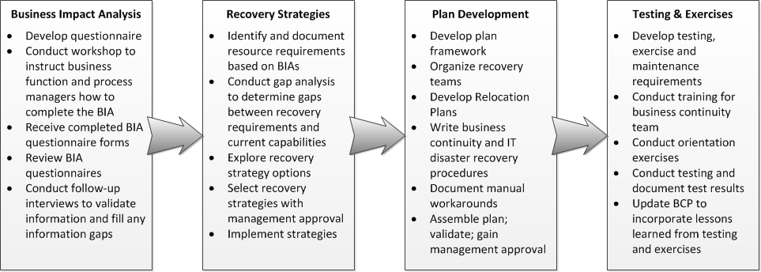
If you need more help getting a business getting your business prepared, try out the new Business Continuity Planning Suite (ZIP Archive - 13 Mb: PC Compatible) developed by DHS’ National Protection and Programs Directorate and FEMA. This software was created for any business with the need to create, improve, or update its business continuity plan. The Suite is scalable for optimal use by organizations of any size and consists of a business continuity plan (BCP) training, automated BCP and disaster recovery plan (DRP) generators, and a self-directed exercise for testing an implemented BCP. Businesses can utilize this solution to maintain normal operations and provide resilience during a disruption.
- Information Technology Plan: A plan to recover computer hardware, connectivity and electronic data to support critical business processes should be developed.
- Employee Assistance & Support: The business preparedness plan should encourage employees and their families to develop family preparedness plans. Plans should also be developed to support the needs of employees following an incident.
- Incident Management: An incident management system is needed to define responsibilities and coordinate activities before, during and following an incident.
- Training: Persons with a defined role in the preparedness program should be trained to do their assigned tasks. All employees should be trained so they can take appropriate protective actions during an emergency.
Training & Exercise
After implementing a preparedness program, it important to regularly train and exercise it to ensure employees understand their role and to identify any gaps that may need remedied. DHSEM’s Training & Exercise team is able to assist with developing a training & exercise plan for your business.
Program Improvement
Budgetary changes, regulatory changes, change to infrastructure, etc. should also trigger a review of the program. Program improvements should also occur each time you exercise your preparedness plans as well as activate for a real emergency. Improvements should also be made based off of other businesses’ exercises and real-world incidents. Incorporating best practices into your plans will only make your business more resilient. In addition gaps and deficiencies identified should be noted and addressed through a corrective action program.
The following are resources recommended by DHS and FEMA to assist you with your business’s preparedness program reviews:
- Lessons Learned Information Sharing - U. S. Department of Homeland Security
- U. S. Chemical Safety and Hazard Investigation Board - The CSB is an independent federal agency charged with investigating industrial chemical accidents. The CSB website provides reports on current and completed investigations as well as videos.
- Technical Report Series - U.S. Fire Administration
- OSHA Compliance Assistance: Success Stories and Case Studies - U.S. Occupational Safety & Health Administration
- Fatality Assessment and Control Evaluation (FACE) Program - National Institute for Occupational Safety and Health, Division of Safety Research
Conclusion
As showcased in this article, the development of a preparedness program, done comprehensively, will take time and require extensive research and communication with those within and outside of your organization. If your business currently does not have a preparedness program, at the very least an Emergency Action Plan, bring this to the attention of your supervisor, explaining its importance in your workplace, using the resources provided in this article and on the Ready.gov website as support. Always remember and communicate to others that being a prepared business could means lives are saved when an incident occurs. A business is nothing without its employees and customers, so taking measures ensure their safety is of vital importance.

Department of Homeland Security, Plan and Prepare for Disasters, web, accessed 10 Aug 2016, https://www.dhs.gov/topic/plan-and-prepare-disasters
Department of Homeland Security and Federal Emergency Management Agency, About the Ready Campaign, web, accessed 15 Aug 2016, https://www.ready.gov/about-us
“Testing” was changed to “Training” due to more current national preparedness language and to match Colorado vernacular
Department of Homeland Security and Federal Emergency Management Agency, Program Coordinator Committee, web, accessed 16 Aug 2016, https://www.ready.gov/program-coordinator-committee
Department of Homeland Security and Federal Emergency Management Agency, Performance Objectives, web, accessed 16 Aug 2016, https://www.ready.gov/performance-objectives
Department of Homeland Security and Federal Emergency Management Agency, Planning, web, accessed 16 Aug 2016, https://www.ready.gov/program-administration
Department of Homeland Security and Federal Emergency Management Agency, Program Management, web. Accessed 16 Aug 2016, https://www.ready.gov/program-management
Contact Colorado Preparedness Program Manager, Fran Santagata, for these templates at Fran.Santagata@state.co.us.
Department of Homeland Security and Federal Emergency Management Agency, Planning, web, accessed 15 Aug 2016, https://www.ready.gov/planning
Department of Homeland Security and Federal Emergency Management Agency, Business Continuity Planning Suite, web, accessed 15 Aug 2016, https://www.ready.gov/business-continuity-planning-suite
Department of Homeland Security and Federal Emergency Management Agency, Implementation, web, accessed 16 Aug 2016, https://www.ready.gov/business/implementation
Contact Colorado Training & Exercise Program Manager Lynn Bailey at Lynn.Bailey@state.co.us
Department of Homeland Security and Federal Emergency Management Agency, Program Improvement, web, accessed 15 Aug 2016, https://www.ready.gov/business/program

